
Project

Interim

Report

On

Online Voting System

(
Using

Java

&

OOP

Concepts)

RU-100-05-00018

Object

Oriented

Programming

with

Java

SESSION:

2025-26

Submitted

By

HIMANSHU

KUMAR

RU-25-10584

Bachelor of Computer Applications in Association With Google

Under

the

Guidance

of

Mr.

Harsh

Multani

SCHOOL OF INFORMATION TECHNOLOGY

RUNGTA

INTERNATIONAL

SKILLS

UNIVERSITY

BHILAI,

CG

(
April

2026)

CERTIFICATE

This is to certify that the Project Interim Report entitled "Online Voting System (Using Core Java & OOP Concepts)" has been submitted by Himanshu Kumar (Registration No. RU-25-10584) of Bachelor of Computer Applications (BCA), Session 2025-26, in partial fulfillment of the requirements for the subject Object Oriented Programming With Java.
The work embodied in this report is original and has been carried out under the guidance of Mr. Harsh Multani, School of Information Technology, Rungta International Skills University, Bhilai, CG.

Project Guide:
Mr. Harsh Multani
School of Information Technology Signature: ____________________________
Head of Department:
School of Information Technology
Rungta International Skills University, Bhilai, CG
Signature: ____________________________
Date: April 2026

ACKNOWLEDGEMENT

I, Himanshu Kumar, student of Bachelor of Computer Applications (BCA with AI ML), Registration No. RU-25-10584, would like to express my sincere gratitude to all those who supported and guided me throughout the completion of this project.
First and foremost, I am deeply thankful to my project guide Mr. Harsh Multani, for their valuable guidance, continuous encouragement, and expert advice during the development of this project. Their support helped me understand Object-Oriented Programming concepts more effectively.
I would also like to thank the faculty members of the School of Information Technology, Rungta International Skills University, Bhilai, for their constant support and motivation throughout the semester.
I am grateful to the Head of Department and the university management for providing the necessary resources and infrastructure that made this project possible.
Finally, I would like to thank my family and friends for their unconditional support and encouragement.
Himanshu Kumar
RU-25-10584
BCA AI ML
Rungta International Skills University, Bhilai, CG
April 2026

Abstract

The Online Voting System is a console-based Java application developed to simulate a secure and efficient voting process. The system allows users to cast votes for candidates using a unique voter ID, ensuring that each voter can vote only once.
The project focuses on implementing Object-Oriented Programming (OOP) concepts such as encapsulation, class design, and method implementation. It also includes validation logic to prevent duplicate voting and ensure fairness.
The system maintains vote counts for each candidate and displays the final results, including the winner. This project helps in understanding how real-world systems can be designed using Java.
Overall, the system improves efficiency, reduces manual errors, and provides a simple yet effective solution for small-scale voting processes.

Introduction

The Online Voting System is developed using Core Java to automate the voting process. Traditional voting systems can be time-consuming and prone to errors. This system provides a digital solution that ensures accuracy, fairness, and efficiency.
The application allows users to vote using a unique ID, prevents duplicate voting, and maintains records of votes.
Key Features:
- Candidate management
- Secure voting using unique voter ID
- Duplicate voting prevention
- Accurate vote counting
- Display of final results and winner

Objectives

The main objectives of this project are:
- To design a voting system using Java classes
- To implement vote counting logic
- To prevent duplicate voting
- To display election results accurately
- To simulate a real-world voting system

Scope

This project is suitable for:
- School elections
- College elections
- Small organizations
Future scope includes:
- GUI-based system using Java Swing
- Database integration
- Online voting system

System Requirements

Hardware Requirements
Component | Requirement
Processor | Intel Core i3 or equivalent
RAM | 4 GB or more
Storage | 100 MB free disk space
Display | Any standard monitor

Software Requirements
Component | Requirement
Operating System | Windows / Linux / macOS
Java Version | Java JDK 8 or above
IDE | VS Code / Eclipse / IntelliJ IDEA / Edit Plus
GitHub | For version control and submission

Methodology

- Step 1: Create Candidate class with name and vote count
- Step 2: Implement vote() method
- Step 3: Use HashSet to store voter IDs
- Step 4: Validate duplicate voting
- Step 5: Accept user input (ID & choice)
- Step 6: Update vote count
- Step 7: Display results and winner

Flowchart

The following describes the logical flow of the Online Voting System:

START → Menu → Enter Voter ID → Check Duplicate →
If Yes → Reject → If No → Vote → Update Count → Show Result → END

Class Diagram

Candidate Class
- Variables: name, votes
- Methods: addVote(), getVotes()
VotingSystem Class
- Variables: candidates list, voter ID set
- Methods: vote(), showResults()

Implementation

The system is implemented using Java OOP concepts:
- Candidate class stores candidate data
- VotingSystem class handles voting logic
- HashSet prevents duplicate voting
- Menu-driven system ensures easy user interaction

1. Candidate Class stores candidate data
The Candidate class is used to store the details of each candidate.
It contains:
- Candidate name
- Vote count
Whenever a vote is cast, the vote count is increased using a method (e.g., addVote()).
👉 In simple terms:
The Candidate class acts as a data holder for candidate information.
2. VotingSystem class handles voting logic
The VotingSystem class controls the entire working of the system.
It is responsible for:
- Taking user input
- Managing candidates
- Handling the voting process
- Displaying results

3. HashSet prevents duplicate voting
A HashSet is a collection that does not allow duplicate values.
In this project:
- Each voter ID is stored in a HashSet
- Before voting, the system checks if the ID already exists
- If it exists → vote is rejected
- If not → vote is allowed

4. Menu-driven system ensures easy user interaction
The system uses a menu-driven interface, such as:
1. Vote
2. View Results
3. Exit
The user selects an option by entering a number, and the system performs the corresponding action.

Sample Input / Output
Below is the expected terminal output when the program is executed:

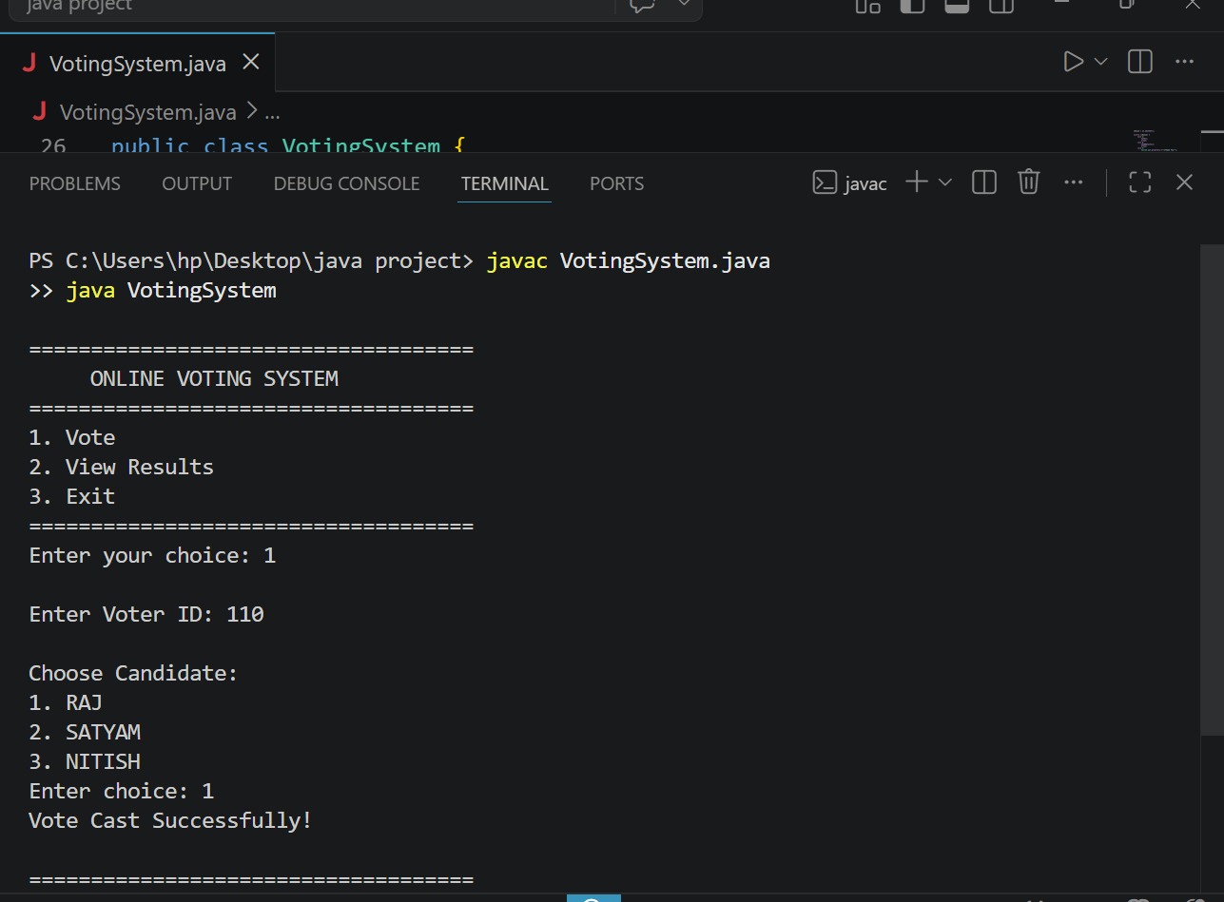

Future Enhancements

- Admin login system
- GUI (Java Swing)
- File/database storage
- Time-based voting
- Multiple elections

Gantt Chart

The following Gantt chart shows the planned timeline for completing the project across 4 weeks:

Task | Week 1 | Week 2 | Week 3 | Week 4 | Status
Project Planning & Understanding | ✓ |  |  |  | Done
Interface & Class Design | ✓ | ✓ |  |  | Done
Java Code Implementation |  | ✓ | ✓ |  | Done
Testing & Bug Fixing |  |  | ✓ |  | Done
Report Writing |  |  | ✓ | ✓ | Done
Final Review & Submission |  |  |  | ✓ | Done

Conclusion

The Online Voting System successfully demonstrates the practical application of Object-Oriented Programming concepts in Java.
The system ensures fairness by preventing duplicate voting and provides accurate results. It is efficient, user-friendly, and can be expanded into a full-scale application.

References

- Java: The Complete Reference – Herbert Schildt
- Oracle Java Documentation
- GeeksforGeeks
- W3Schools

